**Batch: C - 3 Roll No : 16010122096**

**Experiment No: 1**

|  |
| --- |
| **Title :** Introduction to Matlab. |

**Objective :** To familiarize the beginner to MATLAB by introducing the basic featuresand commands of the program.

**Expected Outcome of Experiment :**

|  |  |
| --- | --- |
| **Course Outcome** | **Description** |
| **CO-1** | Identify various discrete time signals and systems and perform signal manipulation |

**Books / Journals / Websites referred :**

1. http://www.mathworks.com/support/
2. www.math.mtu.edu/~msgocken/intro/intro.html
3. [www.mccormick.northwestern.edu/docs/efirst/matlab.pdf](http://www.mccormick.northwestern.edu/docs/efirst/matlab.pdf)

* **Pre-Lab Prior concepts :**
* **INTRODUCTION TO MATLAB**

MATLAB (MATrix LABoratory) is an interactive software system for numerical computations and graphics. As the name suggests, MATLAB is especially designed for matrix computations: solving systems of linear equations, performing matrix transformations, factoring matrices, and so forth. In addition, it has a variety of graphical capabilities, and can be extended through programs written in its own programming language.

* **KEY FEATURES**
* High-level language for numerical computation, visualization, and application development.
* Interactive environment for iterative exploration, design, and problem solving.
* Mathematical functions for linear algebra, statistics, Fourier analysis, filtering, optimization, numerical integration, and solving ordinary differential equations.
* Built-in graphics for visualizing data and tools for creating custom plots.
* Development tools for improving code quality and maintainability and maximizing performance.
* Tools for building applications with custom graphical interfaces.
* Functions for integrating MATLAB based algorithms with external applications and languages such as C, Java, .NET.
* **GETTING STARTED**

Double click on the MATLAB icon. The MATLAB window should come up on your screen. It looks like this :

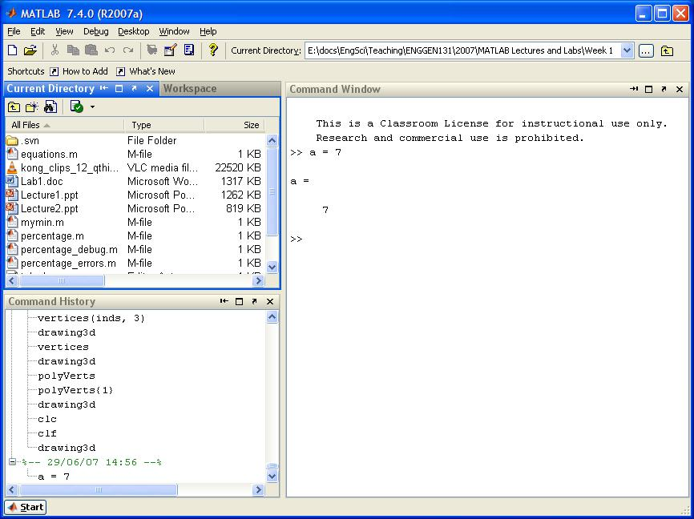

The main window on the right is called the Command Window. This is the window in which you interact with MATLAB. Once the MATLAB prompt >> is displayed, all MATLAB commands are executed from this window. In the figure, you can see that we execute the command:

>> a = 7

In the top left corner you can view the Workspace window and the Current Directory window. Swap from one to the other by clicking on the appropriate tab. Note that when you first start up MATLAB, the workspace window is empty. However, as you execute commands in the Command window, the Workspace window will show all variables that you create in your current MATLAB session. In this example, the workspace contains the variable a.

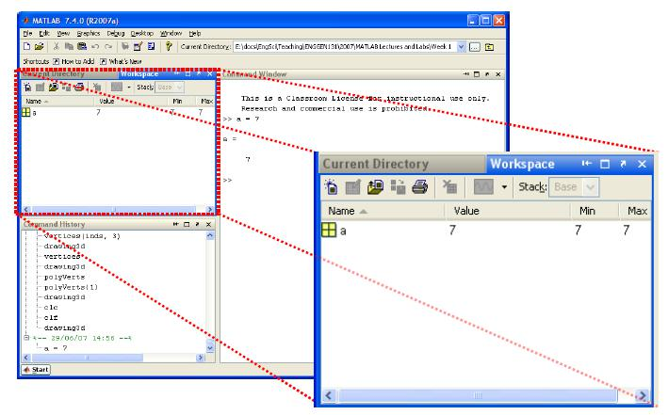

In the bottom left corner you can see the Command History window, which simply gives a chronological list of all MATLAB commands that you used.

During the MATLAB sessions you will create files to store programs or workspaces. Therefore, create an appropriate folder to store the lab files.

* **THE MATLAB HELP SYSTEM**

MATLAB’s help system provides information to assist you while using MATLAB.

Select Help for MATLAB Help to open the help system.

We can then browse the commands via the Contents window, look through the Index of commands or Search for keywords or phrases within the documentation. This is the most comprehensive documentation for MATLAB and is the best place to find out what you need. You can also start the MATLAB Help using the help win command.

A faster way to find out information about commands is via the help command. If you just type help and hit return, you will be presented with a menu of help options. If you type help <command>, MATLAB will provide help for that particular command. For example, help hist will call up information on the hist command, which produces histograms. Note that the help command only displays a short summary of how to use the command you are interested in. For more detailed help documentation, use the doc command. For example, doc hist will display the full documentation of the hist command, including examples of how to use it and sample output.

* **Matlab Commands used for Signal and Image processing :**

Find greatest of three numbers

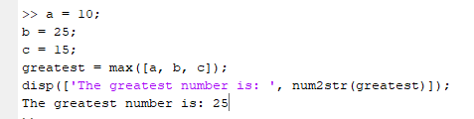

a = 10; b = 25; c = 15; greatest = max([a, b, c]); disp(['The greatest number is: ', num2str(greatest)]);

Perform matrix operations: addition, subtraction, multiplication

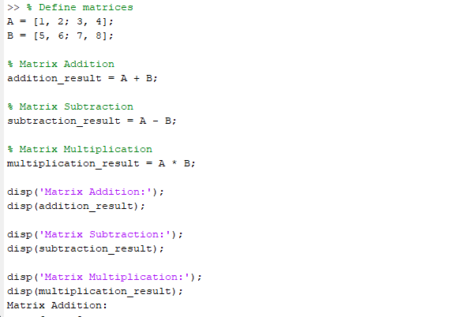

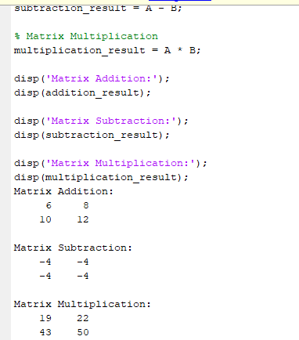

**% Define matrices**

**A = [1, 2; 3, 4];**

**B = [5, 6; 7, 8];**

**% Matrix Addition**

**addition_result = A + B;**

**% Matrix Subtraction**

**subtraction_result = A - B;**

**% Matrix Multiplication**

**multiplication_result = A * B;**

**disp('Matrix Addition:');**

**disp(addition_result);**

**disp('Matrix Subtraction:');**

**disp(subtraction_result);**

**disp('Matrix Multiplication:');**

**disp(multiplication_result);**

Sine and Cosine plot

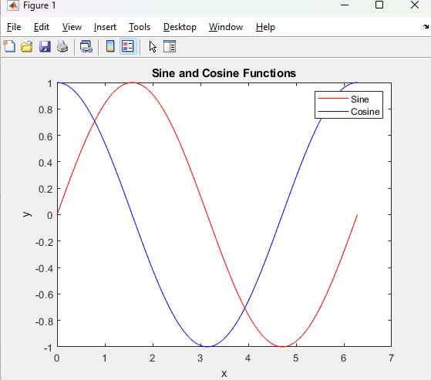

**% Create an array of x values from 0 to 2*pi**

**x = linspace(0, 2*pi, 100);**

**% Compute sine and cosine values**

**y_sin = sin(x);**

**y_cos = cos(x);**

**% Plotting the sine and cosine curves**

**plot(x, y_sin, 'r', 'DisplayName', 'Sine');**

**hold on;**

**plot(x, y_cos, 'b', 'DisplayName', 'Cosine');**

**% Adding labels and title**

**xlabel('x');**

**ylabel('y');**

**title('Sine and Cosine Functions');**

**legend;**

**% Display the plot**

**hold off;**

imread()  
imresize()  
rgb2gray()

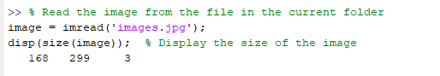

**% Read the image from the file in the current folder**

**image = imread('images.jpg');**

**disp(size(image)); % Display the size of the image**

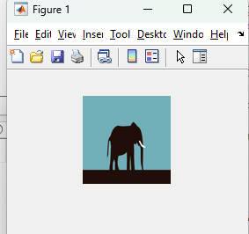

**% Resize the image to a new size (e.g., 100x100)**

**resized_image = imresize(image, [100, 100]);**

**% Display the resized image**

**imshow(resized_image);**

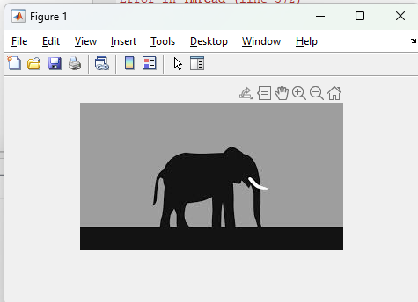

**% Convert the image to grayscale**

**gray_image = rgb2gray(image);**

**% Display the grayscale image**

**imshow(gray_image);**

**Conclusion :** Thus, we have studied and explored and implemented Matlab and Matlab commands which is used for Signal and Image processing.

* **Post-Lab Descriptive Questions :**

1. **Create a vector of the even whole numbers between 31 and 75.**

**Ans:**

even_numbers = 32:2:74;

% Even numbers between 31 and 75 disp(even_numbers);

1. **Let x = [2 5 1 6].**
2. Add 16 to each element
3. Add 3 to just the odd-index elements
4. Compute the square root of each element
5. Compute the square of each element

**Ans:**

1. x = [2 5 1 6]; x_plus_16 = x + 16; % Add 16 to each element disp(x_plus_16);
2. x = [2 5 1 6]; x_odd_plus_3 = x; % Copy x x_odd_plus_3(1:2:end) = x_odd_plus_3(1:2:end) + 3; % Add 3 to odd-index elements disp(x_odd_plus_3);
3. x = [2 5 1 6];

x_sqrt = sqrt(x); % Compute the square root of each element

disp(x_sqrt);

1. x = [2 5 1 6];

x_square = x.^2;

disp(x_square);

1. **Let x = [3 2 6 8]' and y = [4 1 3 5]' (NB. x and y should be column vectors).**
   1. Add the sum of the elements in x to y
   2. Raise each element of x to the power specified by the corresponding element in y.
   3. Divide each element of y by the corresponding element in x
   4. Multiply each element in x by the corresponding element in y, calling the result "z".
   5. Add up the elements in z and assign the result to a variable called "w".
   6. Compute x' *y - w and interpret the result

**Ans:**

**a) y_plus_sum_x = y + sum(x);**

**disp(y_plus_sum_x);**

**b) x_power_y = x.^y;**

**disp(x_power_y);**

**c) x_div_y = y ./ x;**

**disp(x_div_y);**

**d) z = x .* y;**

**disp(z);**

**e) w = sum(z);**

**disp(w);**

**f) result = x' * y - w;**

**disp(result);**

**4. Create a vector x with the elements,**

**xn = (-1)**n+1**/(2n-1)**

Add up the elements of the version of this vector that has 100 elements.

Ans:

n = 1:100; % Create the vector n from 1 to 100

x_n = ((-1).^(n+1)) ./ (2*n - 1); % Apply the formula for each n

sum_x_n = sum(x_n); % Add up the elements of the vector

disp(sum_x_n);

5. **Given the array A = [2 4 1; 6 7 2; 3 5 9], provide the commands needed to**

a. Assign the first row of A to a vector called x1

b. Assign the last 2 rows of A to an array called y

c. Compute the sum over the columns of A

d. Compute the sum over the rows of A

e. Compute the standard error of the mean of each column of A (NB. the standard error of the mean is defined as the standard deviation divided by the square root of the number of elements used to compute the mean.)

Ans:

a) x1 = A(1, :);

disp(x1);

b) y = A(2:3, :);

disp(y);

c) sum_columns = sum(A);

disp(sum_columns);

d) sum_rows = sum(A, 2);

disp(sum_rows);

e) std_dev = std(A);

n = size(A, 1);

std_error = std_dev / sqrt(n);

disp(std_error);